Project-2

QUANTIZATION

EE5356 Digital Image Processing

Dr. K. R. Rao

Submitted By:

Ashutosh Desai

UTA ID:1001388602

Email:ashutoshrajesh.desai@mavs.uta.edu

Feb 15th 2018

**EE5356 LAB Assignment #2**

**Quantization**

**Apply the following 3 quantization schemes to a test image (8bpp 256 level gray scale).**

**1) Uniform quantizer**

**Calculate and compare those three quantizers (128,64,and 32 levels) in terms of the PSNR and MSE.**

**2) Contrast quantizer (See Figure 4.21 in the text book pp.120)**

**Use the equation (4.65) to design 3 different uniform quantizers. Let**α **= 1 and**β **=1/3. Those quantizers have the different number of quantization levels, 40, 60, and 80, respectively, and then compare in terms of the PSNR and MSE.**

**3)Pseudorandom quantizer (See Figure 4.22 in the textbook pp.121) Design a 3bit quantizer. Use three different values of A for pseudorandom noise generator and compare in terms of the PSNR and MSE.**

**NOTE:**

**You may choose a test image from the UTA DIP website at http://www-ee.uta.edu/dip**

**or Dr.Rafael Gonzalez’s web site at http://www.imageprocessingbook.com/downloads/book_images_ downloads.htm . (All the images are in jpeg format.)**

**Also, go to data base in the class website..**

PART (A): UNIFORM QUANTIZER

clc;

clear all;

close all;

orignal_img_1 = imread('D:\STUDY\DIP\Test img\cameraman.bmp');

subplot(2,2,1);

imshow('orignal_img_1');

title('Actual Image');

orignal_img = double(orignal_img_1);

for p=5:7

Variable= 2^p;

Variable_1=256/(Variable);

tk(1)=0;

for m=2:(Variable+1)

tk(m)=tk(m-1)+Variable_1;

end

for m=1:(Variable)

rk(m)=tk(m)+Variable_1/2;

end

% Quantization process

for m=1:256

for n=1:256

for k=1:Variable

if (orignal_img(m,n) < tk(k+1) && orignal_img(m,n) >= tk(k))

UNI_img(m,n)=rk(k);

end

end

end

end

UNI_img1 = double(UNI_img);

y = orignal_img - UNI_img1;

MSE = sum(sum(power(y,2)))/(256^2); % standard equation for MSE

PSNR = 10*log10((255^2)/MSE); % standard equation for PSNR

UNI_img=uint8(UNI_img);

subplot(2,2,p-3);

imshow(uint8(UNI_img));

title([num2str(Variable),'level Quantized images']);

end

OUTPUT:

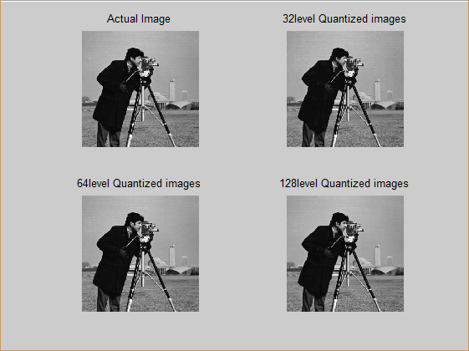

MSE PSNR  
5.4799 40.7430  
1.4899 46.4023  
0.5026 51.1186

PART (B): CONTRAST QUANTIZER

clc;

clear all;

close all;

orignal_img_1 = imread('D:\STUDY\DIP\Test img\cameraman.bmp');

subplot(2,2,1);

imshow(orignal_img_1);

title('Actual Image');

orignal_img = double(orignal_img_1);

for m=5:7

variable= 2^m;

C = (1)*((orignal_img).^(1/3));

tk(1) = min(min(C));

tk(variable+1) = max(max(C));

variable_1 = (tk(variable+1)-tk(1))/variable;

for a=2:(variable)

tk(a)=tk(a-1)+variable_1;

end

for a=1:(variable)

rk(a)=tk(a)+variable_1/2;

end

% Quantization process

for a=1:256

for p=1:256

for q=1:variable

if (C(a,p) < tk(q+1) && C(a,p) >= tk(q))

UNI_img(a,p)=rk(q);

end

end

end

end

U = (UNI_img).^(3);

U_1 = double(U);

y = orignal_img - U_1;

%disp(U1);

MSE = sum(sum(power(y,2)))/(256^2); % standard equation for MSE

disp(MSE);

PSNR = 10*log10((255^2)/MSE); % standard equation for PSNR

disp(PSNR);

subplot(2,2,m-3);

imshow(uint8(U_1));

title([num2str(variable),'level Quantized images']);

end

OUTPUT:

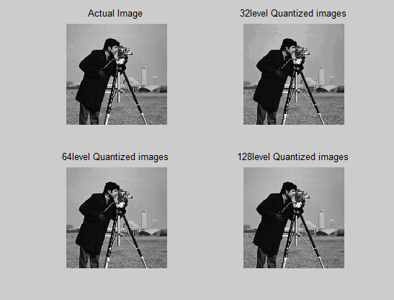  
  
 MSE PSNR  
9.9540 38.1508  
3.2217 43.0499  
1.5607 46.1977

PART (C): PSEUDO-RANDOM NOISE QUANTIZER

clc;

clear all;

close all;

orignal_Img=imread('D:\STUDY\DIP\Test img\cameraman.bmp')

Img = double(orignal_Img);

subplot(2,2,1);

imshow(orignal_Img);

title('Actual image');

Y=5;

for p = 1:3;

PSUDO = (-Y)+(2*Y).*rand(256,'double');

N_img = Img + PSUDO;

Bits = 3;

M = 2 ^ Bits;

Mini = min(min(N_img));

Maxi = max(max(N_img));

ci = (Maxi - Mini)/(M);

Tk(1) = Mini;

for a=1:(M)

Tk(a+1)=Tk(a)+ci;

end

for a=1:(M)

Rk(a)=Tk(a)+(ci/2);

end

for a=1:256

for b=1:256

for k=1:(M)

if N_img(a,b)<Tk(k+1) && N_img(a,b)>=Tk(k)

x1_img(a,b)=Rk(k);

end

end

end

end

x_1 = x1_img - PSUDO;

x_1 = round(x_1);

MSE = sum(sum(power((Img-x_1),2)))/(256^2);

disp(MSE);

PSNR = 10*log10((255^2)/MSE);

disp(PSNR);

x2_img=uint8(x_1);

subplot(2,2,p+1);

imshow(x2_img);

title(['Pseudorandom Image ',num2str(Y)]);

Y=Y+10;

end

OUTPUT:  
  
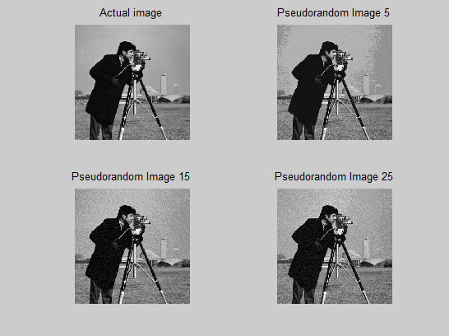  
  
  
  
 MSE PSNR  
80.1298 29.0929  
95.1536 28.3465  
108.4875 27.7770

OBSERVATION:

Thus from the above results following conclusion can be made:-

1. In Analog to Digital Conversion, if all the values are almost equal except for the lower and higher values. Then the signal is called **Uniformly Quantized**.
2. Since visual sensitivity is nearly uniform to just noticeable changes in contrast, the more appropriate method adopted is **Contrast Quantization**.
3. The method of suppressing the contouring effects by adding a small amount of pseudo random noise to the luminance samples before quantization is called **Pseudo-Random Quantization**. The Pseudo random noise is also called **Dither**. This psudo-Random noise eliminates the contouring effects caused by representing the image with less number of levels